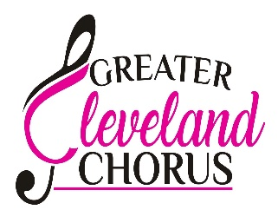
The Greater Cleveland Chorus has an opportunity for current Sweet Adeline members as we prepare to compete at the Sweet Adeline Contest in Columbus, Ohio, October 20-25.2025. We would love to have you join us as a short- term dual member (STDM) on our journey to the Harmony Classic!

Here’s what you need to know:
- Dues for this adventure are $25 a month to GCC. If you belong to a region outside of Region 17, a regional assessment of $120 will be owed.
- A short- term dual member shall pay the equivalent of what membership is paying to cover current costume costs. All costumes will need to be returned within 2 weeks of the International contest.
- Attendance at all rehearsals and performances in Columbus is expected.
- Attendance at all coaching sessions during 2025 is expected.
- Attending as many rehearsals during the year as possible is expected. All rehearsals and coaching will be posted on the GCC website.
- Short- term dual members will audition for membership with members from the Music Team with the HC Contest song and will be approved by the Board of Directors and voted on by the membership.
- All members competing with GCC will have passed vocal and visual audits as determined by the Music Team and Directors. STDM may submit voice and video audits via recordings if unable to complete in person.
- If you are interested in becoming a short- term dual member with us please contact membership coordinator, membership@gcchorus.com no later than June 1, 2025.

Here’s what we want you to know:
- If you choose to join us on this adventure, we will strive to make this journey fun, educational, fulfilling, and memorable!
- If you choose to join us on this adventure, we hope you’ll jump in with both feet!
- We promise you’ll make new friends and perhaps reconnect with friends from the past.
- You’ll get to work with some great coaches from SA and BHS plus learn a ton from our dynamic duo, co-directors, Chelsea Selvaggio and Shannon Lange (lead and tenor from current International 5th place Tenacious Quartet).

Greater Cleveland Chorus meets every Tuesday night from 7-10 PM
Independence United Methodist Church
6615 Brecksville Rd.
Independence, OH 44131

QUESTIONS? Please contact membership@gcchorus.com
In Harmony,
The Greater Cleveland Chorus Co-Directors, Shannon Lange and Chelsea Selvaggio and Music Team

2025 Schedule
January 14-15 with Rob Mance
March 21-23 Retreat with Steve Tramack, BHS Music Judge, Arranger, and coach to many SAI, HI, BHS champ choruses and quartets
Regional contest, May 8-11, 2025
Future coaching dates TBD
September 12-14/sing at Fall Harmony Weekend
October date TBD for Friends and Family Show
October 21st/Tuesday—Contestant #1 in the AA Harmony Classic Contest

